Abstract class in Java

A class which is declared with the abstract keyword is known as an abstract class in [Java](https://www.javatpoint.com/java-tutorial). It can have abstract and non-abstract methods (method with the body).

Before learning the Java abstract class, let's understand the abstraction in Java first.

Abstraction in Java

**Abstraction** is a process of hiding the implementation details and showing only functionality to the user.

Another way, it shows only essential things to the user and hides the internal details, for example, sending SMS where you type the text and send the message. You don't know the internal processing about the message delivery.

Abstraction lets you focus on what the [object](https://www.javatpoint.com/object-and-class-in-java) does instead of how it does it.

Ways to achieve Abstraction

There are two ways to achieve abstraction in java

1. Abstract class (0 to 100%)
2. Interface (100%)

Abstract class in Java

A class which is declared as abstract is known as an **abstract class**. It can have abstract and non-abstract methods. It needs to be extended and its method implemented. It cannot be instantiated.

Points to Remember

* An abstract class must be declared with an abstract keyword.
* It can have abstract and non-abstract methods.
* It cannot be instantiated.
* It can have [constructors](https://www.javatpoint.com/java-constructor) and static methods also.
* It can have final methods which will force the subclass not to change the body of the method.

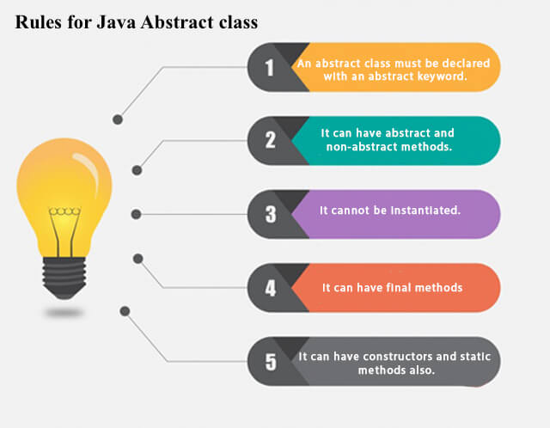

**Example of abstract class**

1. **abstract** **class** A{}

Abstract Method in Java

A method which is declared as abstract and does not have implementation is known as an abstract method.

**Example of abstract method**

1. **abstract** **void** printStatus();//no method body and abstract

Example of Abstract class that has an abstract method

In this example, Bike is an abstract class that contains only one abstract method run. Its implementation is provided by the Honda class.

1. **abstract** **class** Bike{
2. **abstract** **void** run();
3. }
4. **class** Honda4 **extends** Bike{
5. **void** run(){System.out.println("running safely");}
6. **public** **static** **void** main(String args[]){
7. Bike obj = **new** Honda4();
8. obj.run();
9. }
10. }

[**Test it Now**](https://www.javatpoint.com/opr/test.jsp?filename=Honda4)

running safely

Understanding the real scenario of Abstract class

In this example, Shape is the abstract class, and its implementation is provided by the Rectangle and Circle classes.

Mostly, we don't know about the implementation class (which is hidden to the end user), and an object of the implementation class is provided by the **factory method**.

A **factory method** is a method that returns the instance of the class. We will learn about the factory method later.

In this example, if you create the instance of Rectangle class, draw() method of Rectangle class will be invoked.

*File: TestAbstraction1.java*

1. **abstract** **class** Shape{
2. **abstract** **void** draw();
3. }
4. //In real scenario, implementation is provided by others i.e. unknown by end user
5. **class** Rectangle **extends** Shape{
6. **void** draw(){System.out.println("drawing rectangle");}
7. }
8. **class** Circle1 **extends** Shape{
9. **void** draw(){System.out.println("drawing circle");}
10. }
11. //In real scenario, method is called by programmer or user
12. **class** TestAbstraction1{
13. **public** **static** **void** main(String args[]){
14. Shape s=**new** Circle1();//In a real scenario, object is provided through method, e.g., getShape() method
15. s.draw();
16. }
17. }

[**Test it Now**](https://www.javatpoint.com/opr/test.jsp?filename=TestAbstraction1)

drawing circle

Another example of Abstract class in java

*File: TestBank.java*

1. **abstract** **class** Bank{
2. **abstract** **int** getRateOfInterest();
3. }
4. **class** SBI **extends** Bank{
5. **int** getRateOfInterest(){**return** 7;}
6. }
7. **class** PNB **extends** Bank{
8. **int** getRateOfInterest(){**return** 8;}
9. }
11. **class** TestBank{
12. **public** **static** **void** main(String args[]){
13. Bank b;
14. b=**new** SBI();
15. System.out.println("Rate of Interest is: "+b.getRateOfInterest()+" %");
16. b=**new** PNB();
17. System.out.println("Rate of Interest is: "+b.getRateOfInterest()+" %");
18. }}

[**Test it Now**](https://www.javatpoint.com/opr/test.jsp?filename=TestBank)

Rate of Interest is: 7 %

Rate of Interest is: 8 %

Abstract class having constructor, data member and methods

An abstract class can have a data member, abstract method, method body (non-abstract method), constructor, and even main() method.

*File: TestAbstraction2.java*

1. //Example of an abstract class that has abstract and non-abstract methods
2. **abstract** **class** Bike{
3. Bike(){System.out.println("bike is created");}
4. **abstract** **void** run();
5. **void** changeGear(){System.out.println("gear changed");}
6. }
7. //Creating a Child class which inherits Abstract class
8. **class** Honda **extends** Bike{
9. **void** run(){System.out.println("running safely..");}
10. }
11. //Creating a Test class which calls abstract and non-abstract methods
12. **class** TestAbstraction2{
13. **public** **static** **void** main(String args[]){
14. Bike obj = **new** Honda();
15. obj.run();
16. obj.changeGear();
17. }
18. }

[**Test it Now**](https://www.javatpoint.com/opr/test.jsp?filename=TestAbstraction2)

bike is created

running safely..

gear changed

Rule: If there is an abstract method in a class, that class must be abstract.

1. **class** Bike12{
2. **abstract** **void** run();
3. }

[**Test it Now**](https://www.javatpoint.com/opr/test.jsp?filename=Bike12)

compile time error

Rule: If you are extending an abstract class that has an abstract method, you must either provide the implementation of the method or make this class abstract.

Another real scenario of abstract class

The abstract class can also be used to provide some implementation of the [interface](https://www.javatpoint.com/interface-in-java). In such case, the end user may not be forced to override all the methods of the interface.

*Note: If you are beginner to java, learn interface first and skip this example.*

1. **interface** A{
2. **void** a();
3. **void** b();
4. **void** c();
5. **void** d();
6. }
8. **abstract** **class** B **implements** A{
9. **public** **void** c(){System.out.println("I am c");}
10. }
12. **class** M **extends** B{
13. **public** **void** a(){System.out.println("I am a");}
14. **public** **void** b(){System.out.println("I am b");}
15. **public** **void** d(){System.out.println("I am d");}
16. }
18. **class** Test5{
19. **public** **static** **void** main(String args[]){
20. A a=**new** M();
21. a.a();
22. a.b();
23. a.c();
24. a.d();
25. }}

[**Test it Now**](https://www.javatpoint.com/opr/test.jsp?filename=Test5)

Output:I am a

I am b

I am c

I am d

# Interface in Java

1. [Interface](https://www.javatpoint.com/interface-in-java)
2. [Example of Interface](https://www.javatpoint.com/interface-in-java#interfaceex)
3. [Multiple inheritance by Interface](https://www.javatpoint.com/interface-in-java#interfacemultiple)
4. [Why multiple inheritance is supported in Interface while it is not supported in case of class.](https://www.javatpoint.com/interface-in-java#interfacewhynot)
5. [Marker Interface](https://www.javatpoint.com/interface-in-java#interfacemarker)
6. [Nested Interface](https://www.javatpoint.com/nested-interface)

An **interface in Java** is a blueprint of a class. It has static constants and abstract methods.

The interface in Java is a mechanism to achieve [*abstraction*](https://www.javatpoint.com/abstract-class-in-java). There can be only abstract methods in the Java interface, not method body. It is used to achieve abstraction and multiple [inheritance in Java](https://www.javatpoint.com/inheritance-in-java).

In other words, you can say that interfaces can have abstract methods and variables. It cannot have a method body.

Java Interface also **represents the IS-A relationship**.

It cannot be instantiated just like the abstract class.

Since Java 8, we can have **default and static methods** in an interface.

Since Java 9, we can have **private methods** in an interface.

## Why use Java interface?

There are mainly three reasons to use interface. They are given below.

* It is used to achieve abstraction.
* By interface, we can support the functionality of multiple inheritance.
* It can be used to achieve loose coupling.

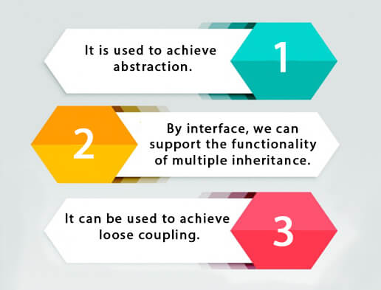

## How to declare an interface?

An interface is declared by using the interface keyword. It provides total abstraction; means all the methods in an interface are declared with the empty body, and all the fields are public, static and final by default. A class that implements an interface must implement all the methods declared in the interface.

### Syntax:

1. **interface** <interface_name>{
3. // declare constant fields
4. // declare methods that abstract
5. // by default.
6. }

## Java 8 Interface Improvement

Since [Java 8](https://www.javatpoint.com/java-8-features), interface can have default and static methods which is discussed later.

## Internal addition by the compiler

#### The Java compiler adds public and abstract keywords before the interface method. Moreover, it adds public, static and final keywords before data members.

In other words, Interface fields are public, static and final by default, and the methods are public and abstract.

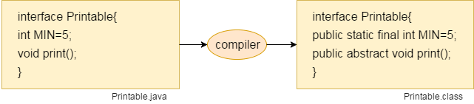

#### The relationship between classes and interfaces

As shown in the figure given below, a class extends another class, an interface extends another interface, but a **class implements an interface**.

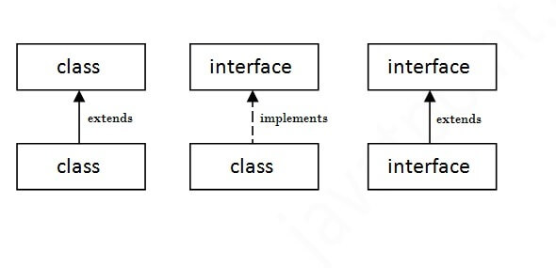

## Java Interface Example

In this example, the Printable interface has only one method, and its implementation is provided in the A6 class.

1. **interface** printable{
2. **void** print();
3. }
4. **class** A6 **implements** printable{
5. **public** **void** print(){System.out.println("Hello");}
7. **public** **static** **void** main(String args[]){
8. A6 obj = **new** A6();
9. obj.print();
10. }
11. }

[**Test it Now**](https://www.javatpoint.com/opr/test.jsp?filename=A6)

Output:

Hello

## Java Interface Example: Drawable

In this example, the Drawable interface has only one method. Its implementation is provided by Rectangle and Circle classes. In a real scenario, an interface is defined by someone else, but its implementation is provided by different implementation providers. Moreover, it is used by someone else. The implementation part is hidden by the user who uses the interface.

*File: TestInterface1.java*

1. //Interface declaration: by first user
2. **interface** Drawable{
3. **void** draw();
4. }
5. //Implementation: by second user
6. **class** Rectangle **implements** Drawable{
7. **public** **void** draw(){System.out.println("drawing rectangle");}
8. }
9. **class** Circle **implements** Drawable{
10. **public** **void** draw(){System.out.println("drawing circle");}
11. }
12. //Using interface: by third user
13. **class** TestInterface1{
14. **public** **static** **void** main(String args[]){
15. Drawable d=**new** Circle();//In real scenario, object is provided by method e.g. getDrawable()
16. d.draw();
17. }}

[**Test it Now**](https://www.javatpoint.com/opr/test.jsp?filename=TestInterface1)

Output:

drawing circle

## Java Interface Example: Bank

Let's see another example of java interface which provides the implementation of Bank interface.

*File: TestInterface2.java*

1. **interface** Bank{
2. **float** rateOfInterest();
3. }
4. **class** SBI **implements** Bank{
5. **public** **float** rateOfInterest(){**return** 9.15f;}
6. }
7. **class** PNB **implements** Bank{
8. **public** **float** rateOfInterest(){**return** 9.7f;}
9. }
10. **class** TestInterface2{
11. **public** **static** **void** main(String[] args){
12. Bank b=**new** SBI();
13. System.out.println("ROI: "+b.rateOfInterest());
14. }}

[**Test it Now**](https://www.javatpoint.com/opr/test.jsp?filename=TestInterface2)

Output:

ROI: 9.15

## Multiple inheritance in Java by interface

If a class implements multiple interfaces, or an interface extends multiple interfaces, it is known as multiple inheritance.

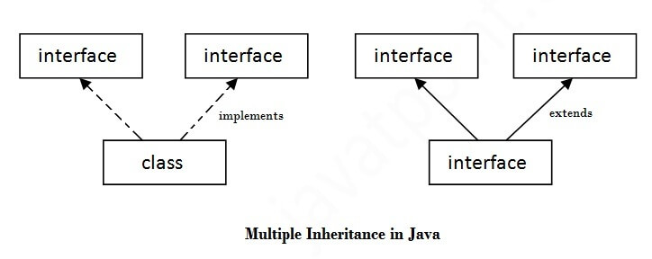

1. **interface** Printable{
2. **void** print();
3. }
4. **interface** Showable{
5. **void** show();
6. }
7. **class** A7 **implements** Printable,Showable{
8. **public** **void** print(){System.out.println("Hello");}
9. **public** **void** show(){System.out.println("Welcome");}
11. **public** **static** **void** main(String args[]){
12. A7 obj = **new** A7();
13. obj.print();
14. obj.show();
15. }
16. }

[**Test it Now**](https://www.javatpoint.com/opr/test.jsp?filename=A7)

Output:Hello

Welcome

## Q) Multiple inheritance is not supported through class in java, but it is possible by an interface, why?

As we have explained in the inheritance chapter, multiple inheritance is not supported in the case of [class](https://www.javatpoint.com/object-and-class-in-java) because of ambiguity. However, it is supported in case of an interface because there is no ambiguity. It is because its implementation is provided by the implementation class. For example:

1. **interface** Printable{
2. **void** print();
3. }
4. **interface** Showable{
5. **void** print();
6. }
8. **class** TestInterface3 **implements** Printable, Showable{
9. **public** **void** print(){System.out.println("Hello");}
10. **public** **static** **void** main(String args[]){
11. TestInterface3 obj = **new** TestInterface3();
12. obj.print();
13. }
14. }

[**Test it Now**](https://www.javatpoint.com/opr/test.jsp?filename=TestInterface3)

Output:

Hello

As you can see in the above example, Printable and Showable interface have same methods but its implementation is provided by class TestTnterface1, so there is no ambiguity.

## Interface inheritance

A class implements an interface, but one interface extends another interface.

1. **interface** Printable{
2. **void** print();
3. }
4. **interface** Showable **extends** Printable{
5. **void** show();
6. }
7. **class** TestInterface4 **implements** Showable{
8. **public** **void** print(){System.out.println("Hello");}
9. **public** **void** show(){System.out.println("Welcome");}
11. **public** **static** **void** main(String args[]){
12. TestInterface4 obj = **new** TestInterface4();
13. obj.print();
14. obj.show();
15. }
16. }

[**Test it Now**](https://www.javatpoint.com/opr/test.jsp?filename=TestInterface4)

Output:

Hello

Welcome

## Java 8 Default Method in Interface

Since Java 8, we can have method body in interface. But we need to make it default method. Let's see an example:

*File: TestInterfaceDefault.java*

1. **interface** Drawable{
2. **void** draw();
3. **default** **void** msg(){System.out.println("default method");}
4. }
5. **class** Rectangle **implements** Drawable{
6. **public** **void** draw(){System.out.println("drawing rectangle");}
7. }
8. **class** TestInterfaceDefault{
9. **public** **static** **void** main(String args[]){
10. Drawable d=**new** Rectangle();
11. d.draw();
12. d.msg();
13. }}

[**Test it Now**](https://www.javatpoint.com/opr/test.jsp?filename=TestInterfaceDefault)

Output:

drawing rectangle

default method

## Java 8 Static Method in Interface

Since Java 8, we can have static method in interface. Let's see an example:

*File: TestInterfaceStatic.java*

1. **interface** Drawable{
2. **void** draw();
3. **static** **int** cube(**int** x){**return** x*x*x;}
4. }
5. **class** Rectangle **implements** Drawable{
6. **public** **void** draw(){System.out.println("drawing rectangle");}
7. }
9. **class** TestInterfaceStatic{
10. **public** **static** **void** main(String args[]){
11. Drawable d=**new** Rectangle();
12. d.draw();
13. System.out.println(Drawable.cube(3));
14. }}

[**Test it Now**](https://www.javatpoint.com/opr/test.jsp?filename=TestInterfaceStatic)

Output:

drawing rectangle

27

## Q) What is marker or tagged interface?

An interface which has no member is known as a marker or tagged interface, for example, [Serializable](https://www.javatpoint.com/serialization-in-java), Cloneable, Remote, etc. They are used to provide some essential information to the JVM so that JVM may perform some useful operation.

1. //How Serializable interface is written?
2. **public** **interface** Serializable{
3. }

#### Nested Interface in Java

Note: An interface can have another interface which is known as a nested interface. We will learn it in detail in the [nested classes](https://www.javatpoint.com/java-inner-class) chapter. For example:

1. **interface** printable{
2. **void** print();
3. **interface** MessagePrintable{
4. **void** msg();
5. }
6. }

Difference between abstract class and interface

Abstract class and interface both are used to achieve abstraction where we can declare the abstract methods. Abstract class and interface both can't be instantiated.

But there are many differences between abstract class and interface that are given below.

|  |  |
| --- | --- |
| **Abstract class** | **Interface** |
| 1) Abstract class can **have abstract and non-abstract** methods. | Interface can have **only abstract** methods.  Since Java 8, it can have **default and**  **static methods** also. |
| 2) Abstract class **doesn't support multiple inheritance**. | Interface **supports multiple inheritance**. |
| 3) Abstract class **can have final, non-final, static and non-static variables**. | Interface has **only static and final variables**. |
| 4) Abstract class **can provide the implementation of interface**. | Interface **can't provide the implementation**  **of abstract class**. |
| 5) The **abstract keyword** is used to declare abstract class. | The **interface keyword** is used to declare interface. |
| 6) An **abstract class** can extend another Java class and implement multiple Java interfaces. | An **interface** can extend another Java interface  only. |
| 7) An **abstract class** can be extended using keyword "extends". | An **interface** can be implemented using  keyword "implements". |
| 8) A Java **abstract class** can have class members like private, protected, etc. | Members of a Java interface are public by default. |
| 9)**Example:** public abstract class Shape{ public abstract void draw(); } | **Example:** public interface Drawable{ void draw(); } |

Simply, abstract class achieves partial abstraction (0 to 100%) whereas interface achieves fully abstraction (100%).

Example of abstract class and interface in Java

Let's see a simple example where we are using interface and abstract class both.

1. //Creating interface that has 4 methods
2. **interface** A{
3. **void** a();//bydefault, public and abstract
4. **void** b();
5. **void** c();
6. **void** d();
7. }
9. //Creating abstract class that provides the implementation of one method of A interface
10. **abstract** **class** B **implements** A{
11. **public** **void** c(){System.out.println("I am C");}
12. }
14. //Creating subclass of abstract class, now we need to provide the implementation of rest of the methods
15. **class** M **extends** B{
16. **public** **void** a(){System.out.println("I am a");}
17. **public** **void** b(){System.out.println("I am b");}
18. **public** **void** d(){System.out.println("I am d");}
19. }
21. //Creating a test class that calls the methods of A interface
22. **class** Test5{
23. **public** **static** **void** main(String args[]){
24. A a=**new** M();
25. a.a();
26. a.b();
27. a.c();
28. a.d();
29. }}

[**Test it Now**](https://www.javatpoint.com/opr/test.jsp?filename=Test5)

Output:

I am a

I am b

I am c

I am d

A **java package** is a group of similar types of classes, interfaces and sub-packages.

Package in java can be categorized in two form, built-in package and user-defined package.

There are many built-in packages such as java, lang, awt, javax, swing, net, io, util, sql etc.

Here, we will have the detailed learning of creating and using user-defined packages.

## Advantage of Java Package

1) Java package is used to categorize the classes and interfaces so that they can be easily maintained.

2) Java package provides access protection.

3) Java package removes naming collision.

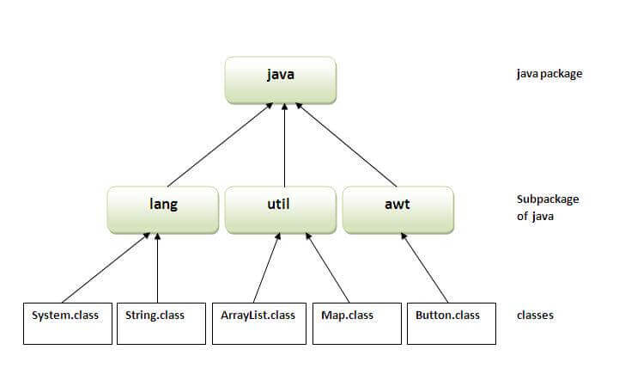

## Simple example of java package

The **package keyword** is used to create a package in java.

1. //save as Simple.java
2. **package** mypack;
3. **public** **class** Simple{
4. **public** **static** **void** main(String args[]){
5. System.out.println("Welcome to package");
6. }
7. }

## How to compile java package

If you are not using any IDE, you need to follow the **syntax** given below:

1. javac -d directory javafilename

For **example**

1. javac -d . Simple.java

The -d switch specifies the destination where to put the generated class file. You can use any directory name like /home (in case of Linux), d:/abc (in case of windows) etc. If you want to keep the package within the same directory, you can use . (dot).

## How to run java package program

You need to use fully qualified name e.g. mypack.Simple etc to run the class.

|  |
| --- |
| **To Compile:** javac -d . Simple.java |
| **To Run:** java mypack.Simple |

Output:Welcome to package

|  |
| --- |
| The -d is a switch that tells the compiler where to put the class file i.e. it represents destination. The . represents the current folder. |

## How to access package from another package?

There are three ways to access the package from outside the package.

1. import package.*;
2. import package.classname;
3. fully qualified name.

#### 1) Using packagename.*

If you use package.* then all the classes and interfaces of this package will be accessible but not subpackages.

The import keyword is used to make the classes and interface of another package accessible to the current package.

## Example of package that import the packagename.*

1. //save by A.java
2. **package** pack;
3. **public** **class** A{
4. **public** **void** msg(){System.out.println("Hello");}
5. }
6. //save by B.java
7. **package** mypack;
8. **import** pack.*;
10. **class** B{
11. **public** **static** **void** main(String args[]){
12. A obj = **new** A();
13. obj.msg();
14. }
15. }

Output:Hello

#### 2) Using packagename.classname

If you import package.classname then only declared class of this package will be accessible.

## Example of package by import package.classname

1. //save by A.java
3. **package** pack;
4. **public** **class** A{
5. **public** **void** msg(){System.out.println("Hello");}
6. }
7. //save by B.java
8. **package** mypack;
9. **import** pack.A;
11. **class** B{
12. **public** **static** **void** main(String args[]){
13. A obj = **new** A();
14. obj.msg();
15. }
16. }

Output:Hello

#### 3) Using fully qualified name

If you use fully qualified name then only declared class of this package will be accessible. Now there is no need to import. But you need to use fully qualified name every time when you are accessing the class or interface.

It is generally used when two packages have same class name e.g. java.util and java.sql packages contain Date class.

## Example of package by import fully qualified name

1. //save by A.java
2. **package** pack;
3. **public** **class** A{
4. **public** **void** msg(){System.out.println("Hello");}
5. }
6. //save by B.java
7. **package** mypack;
8. **class** B{
9. **public** **static** **void** main(String args[]){
10. pack.A obj = **new** pack.A();//using fully qualified name
11. obj.msg();
12. }
13. }

Output:Hello

#### Note: If you import a package, subpackages will not be imported.

If you import a package, all the classes and interface of that package will be imported excluding the classes and interfaces of the subpackages. Hence, you need to import the subpackage as well.

#### Note: Sequence of the program must be package then import then class.

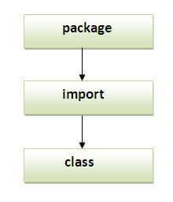

## Subpackage in java

Package inside the package is called the **subpackage**. It should be created **to categorize the package further**.

Let's take an example, Sun Microsystem has definded a package named java that contains many classes like System, String, Reader, Writer, Socket etc. These classes represent a particular group e.g. Reader and Writer classes are for Input/Output operation, Socket and ServerSocket classes are for networking etc and so on. So, Sun has subcategorized the java package into subpackages such as lang, net, io etc. and put the Input/Output related classes in io package, Server and ServerSocket classes in net packages and so on.

#### The standard of defining package is domain.company.package e.g. com.javatpoint.bean or org.sssit.dao.

### Example of Subpackage

1. **package** com.javatpoint.core;
2. **class** Simple{
3. **public** **static** **void** main(String args[]){
4. System.out.println("Hello subpackage");
5. }
6. }

|  |
| --- |
| **To Compile:** javac -d . Simple.java |
| **To Run:** java com.javatpoint.core.Simple |

Output:Hello subpackage

## How to send the class file to another directory or drive?

There is a scenario, I want to put the class file of A.java source file in classes folder of c: drive. For example:

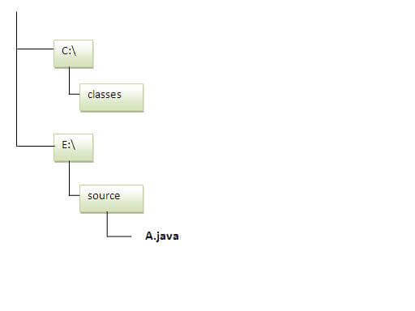

1. //save as Simple.java
2. **package** mypack;
3. **public** **class** Simple{
4. **public** **static** **void** main(String args[]){
5. System.out.println("Welcome to package");
6. }
7. }

### To Compile:

**e:\sources> javac -d c:\classes Simple.java**

### To Run:

|  |
| --- |
| To run this program from e:\source directory, you need to set classpath of the directory where the class file resides. |
| **e:\sources> set classpath=c:\classes;.;** |
| **e:\sources> java mypack.Simple** |

### Another way to run this program by -classpath switch of java:

The -classpath switch can be used with javac and java tool.

To run this program from e:\source directory, you can use -classpath switch of java that tells where to look for class file. For example:

**e:\sources> java -classpath c:\classes mypack.Simple**

Output:Welcome to package

### Ways to load the class files or jar files

|  |
| --- |
| There are two ways to load the class files temporary and permanent. |

* Temporary
  + By setting the classpath in the command prompt
  + By -classpath switch
* Permanent
  + By setting the classpath in the environment variables
  + By creating the jar file, that contains all the class files, and copying the jar file in the jre/lib/ext folder.

#### Rule: There can be only one public class in a java source file and it must be saved by the public class name.

1. //save as C.java otherwise Compilte Time Error
3. **class** A{}
4. **class** B{}
5. **public** **class** C{}

### How to put two public classes in a package?

|  |
| --- |
| If you want to put two public classes in a package, have two java source files containing one public class, but keep the package name same. For example: |

1. //save as A.java
3. **package** javatpoint;
4. **public** **class** A{}
5. //save as B.java
7. **package** javatpoint;
8. **public** **class** B{}